Strange Happening

MVC Group Project

Borislav Lyubomirov Krumov

P1524833X

Business Analyst

[CTEC2902-2017-Y Advanced Programming](https://vle.dmu.ac.uk/webapps/blackboard/execute/launcher?type=Course&id=_441571_1&url=)

# Business Analyst

My role for the MVC group project called “Strange Happening” is a business analyst. According to Bisk (2017), business analyst role is complex and it relates mostly with software projects, logistics, and changes in business process. As a business analyst, my responsibilities were to make sure the website is easy to interact with and provides friendly design. The main purpose of the role is to achieve project goals in efficient way and to suit the customer/company needs (S.Blais, 2010). As a creative person and painter, it was relatively easy for me to create an attractive design of the website. The role was assigned to me because of my advertisement and design skills and interests in it. The goal of MVC project was to create an article website. According to Bisk (2017), the key responsibilities of the business analyst is as follows:

Firstly, business analyst is supposed to have good technical and writing skills, and knowledge of system engineering. Business analyst should discover the business needs. It also needs to be informed about the specification of the product, which is supposed to work on. Business analyst has to follow the project requirements with the stakeholders very carefully. All requirements have to be documented in an easy to understand and friendly format (Bisk, 2017). Moreover, it is very important for a business analyst to ensure the requirements reflect real business needs.

# Team work and what went well

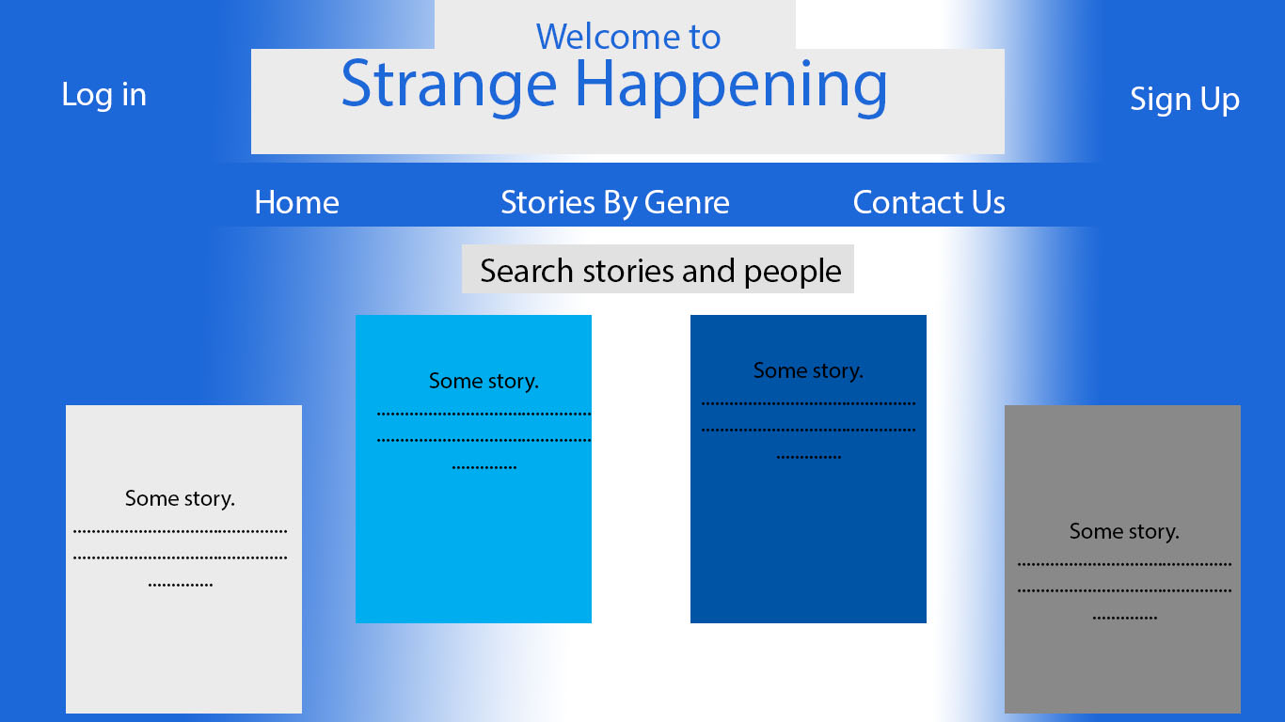

During the meetings, the goals of the project were discussed within a team. As decided, my part of the group project was to work on the website design. The print screen above represents the website design of the main page. Next, the design was discussed with other group members. As a designer, I have decided to use two colours for the background, with the blue on the sides, and white in the middle. The “log in” button appears in the left top corner and on the opposite side, there is a “sign up” button. All the buttons are represented in white colour and the font used is Arial Bold 36.

On the top there is a message box which represents the logo and underneath, there is a text: “Welcome to strange happening”. Underneath the title, there are the web site's buttons:

* Home
* Stories by genre
* Search stories and people
* Contact us

represented in white on a blue background.

Underneath the main buttons, there is a search box, which could be used for quick browsing.

Underneath the search box, the newest stories are represented in different colours.

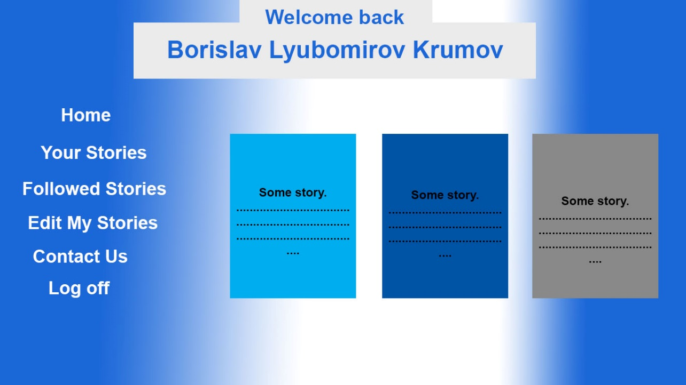

The screenshot above shows how a 'logged in' user's profile looks like. When a user is logged in, there is a welcome text message and user’s name underneath it which is displayed in blue colour. The font size used is Arial Black 36. The option buttons are presented on the left hand side and arranged one under another. User can see his/her stories or browse its favourite stories. Moreover, user can edit its own stories anytime, using the "Edit My Stories" button. "Contact Us" button will reveal information and contact details of the system creators. The last one on the list is a button to “log off”. The font used for the buttons is Arial Black and the size is 36 represented in white colour. The centre of the website will be filled in with articles or stories written by the users.

"Many to many" relationship was used for the MVC project which means that many users can interact with many articles. The class diagram presented below was created and discussed with other team members.

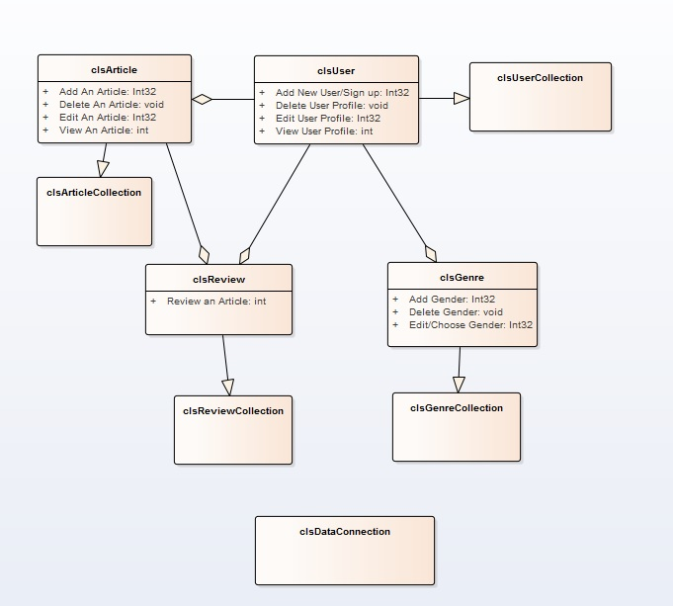

User's interaction with the system:

* Each user can create a profile and use the website. After the account is set up, user can **add**, **edit** and **delete** an article in its own profile. User can also **view**, browse, and comment on other users' articles or stories found in the system.
* Articles are going to be written(**add**) by users and saved in the system database. Each article could be accessed by other “Strange Happening” users. **Edit** option will allow user to edit the content in case of a mistake. Article can also be **deleted**.
* Genre of an article can be **added**, **edited** or **deleted**. This option makes it easier for user to narrow the search and browse through a specific genre.

# What went well and what changes will be made if the project has to be started again

My role was to create the website design. For the real design, the software used is Photoshop. Most of the steps went well. Once the design was created, the next stage was to show it to the other group members. Some changes were applied. For example, the search box was added after the group discussion. The class diagram was created using the enterprise architect software. Once the diagram was created and discussed, the following changes were applied. It was created a class Add, edit, delete (AED) which was not needed. The relationship between the user and articles was not ‘one to many’ as the ‘many to many’ relationship was used. All of the changes were edited and created as it supposed to be in the real system. If the project will need to be started again, it has to be more efficient and more complex. The design might use more than two colours. User might be able to choose colour of the webpage. Option buttons can be added so user will be able to personalise the webpage. For instance, a user might wish to add images, real time, and so on. Live chat option would be very beneficial for a user, as well as ‘contact us’ might be a chat window. Whenever a user is not sure how to interact with the website, he/she can simply ask the admin for help, and shall be answered as soon as possible.

# 

# References

Bisk 2017 Business Analyst Job Description. [Online] Available at

<https://www.villanovau.com/resources/business-analysis/business-analyst-job-description/#.WPuXfmf2aUk>

[Accessed on 22/04/2017]

Steve Blais 2010 What is a Business Analyst? [Online] Available at

<http://www.bridging-the-gap.com/what-is-a-business-analyst-role-anyway/>

[Accessed on 22/04/2017]